Blackburn Challenge

“The Blackburn Challenge is the east coast's premier open-water human-powered boat competition. This 20 mile challenge sends rowers, kayakers and canoeist around
Cape Ann Massachusetts.”

Official Race Website: http://www.blackburnchallenge.com/Blackburn.html

Link to Shutterfly Album

My first Blackburn Challenge - A Personal Odyssey

The fog was so thick for the first 10 miles that at times you could not even see land. It was eerily awesome! The foghorns I could hear, but I never was able to make out any of the lighthouses, except for Annisquam Light, because it is at the mouth of the river. I had my deck compass & the bearings on the chart to follow. Straightsmouth you could barely make out until you were in the channel, and 20 feet from the timekeeper check-in boat.

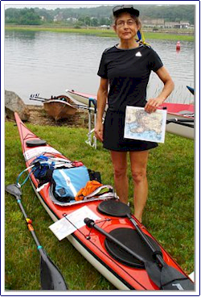
After Straitsmouth, I pulled into the first beach to make some adjustments, and lost one half hour trying to get back out through the surf. I don't know my time, but one half hour subtracted from it would be a rough estimate if I hadn't been so bull-headedly stupid as to stop. As this was my first Blackburn race, it was a personal Odyssey and my only goal was to finish the course, under my own paddle, and not being towed by a rescue boat. I know I wasn't last because I sprinted ahead of a few boats to get to the timekeeper by the Greasy Pole.

It was my first time ever paddling a 20 mile race. I finished with plenty of energy to spare, so next year ... I will try for a good time and paddle like a madwoman. Now that the Race Results have been posted, if I hadn’t made that stop, I would have gotten a bronze medal.

SEA KAYAK SINGLE WOMEN
Year | Place | Place Overall | Boat No. | Time | Crew | Boat Description
2009 | 1 | 101 | 109 | 3:29:11 | Sarah Evertson | Surge 17'8"22.75"
2009 | 2 | 144 | 112 | 3:50:59 | Karen Ristuben | 17'8 surge surge
2009 | 3 | 173 | 106 | 4:21:54 | Tobin Arsenault | 16'22" Wilderness Systems single kayak
2009 | 4 | 183 | 113 | 4:35:42 | Sally Roberts

Link to Shutterfly Album

