Block Island Circumnavigation with ConnYak 9-19-09

ConnYak Bulletin Board
Block Island Survivors Report
Posted By: Erik
Date: Monday, 21 September 2009, at 12:07 a.m.
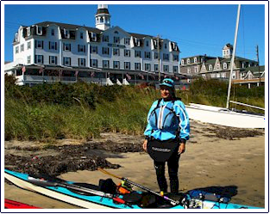
Six brave paddlers (all first time circumnavigators except for me) took to their kayaks in search of high adventure on the third annual ConnYak Block Island Paddle. Going counterclockwise this time, our journey up to the northern tip of the island was fraught with peril as we battled less than ideal tides, fierce headwinds and encountered man-eating sharks (well, Bill Hills did). We came upon a really nice zipper at the sandbar, but due to our relatively slow progress thus far we didn't have much time to play. There were hopes for easy following seas down the backside, but alas, the quartering winds we got were more annoying than helpful as we made our way to a very nice lunch spot at the inlet to the Great Salt Pond. Down and around the beautiful southern end of the island we were treated to easy conditions and exceptional scenery, good thing, as we were all pretty well worn out by this time. Rounding the southeast corner of the island we got hit with the headwinds again, not very strong this time, but enough to make the paddle back up to Old Harbor seem very slow indeed. I think everybody had a good time, but due to the slow progress and the lack of a 7 pm. ferry this year, we all felt a little rushed. Next year, maybe a circumnavigation paddle or we'll pick a day with better tides and a later ferry. There was abundant sunshine, sparkling water, no bugs, capsizes or injuries, and nobody got eaten. Not a bad day.
Link to Shutterfly Album

