Cape Ann Circumnavigation July 11, 2009

Blackburn pre-race practice paddle of the course, 22 miles around Cape Ann, Gloucester, Massachusetts. Saturday's paddle included 2-3 foot seas, breaker and boomers, and a never-ending 10-15 knot wind. It was quite an adventure for Captain Phil & Sailor Sally!

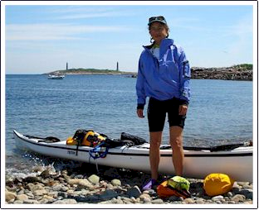
Photos include the Fisherman's Memorial, heroic "Man at the Wheel", at Pavilion Beach in Gloucester Harbor - statue clad in foul-weather gear leaning over a ship's wheel and looking out to sea. It commemorates Gloucester's 300th anniversary & memorializes the large number of Gloucester fishermen who have lost their lives at sea.

The twin stone lighthouse towers (123 feet high), built in1861, are on Thacher Island, less than a mile off Rockport. Thacher was an early British settler who was shipwrecked on the island in 1635.

The "Greasy Pole" an odd-looking structure in the Harbor, and is a telephone pole hanging sideways, used for a contest something like log rolling in which youths see how far out on the pole they can clamber before slithering off.

Link to Shutterfly Album

