22 miles on the Hudson River

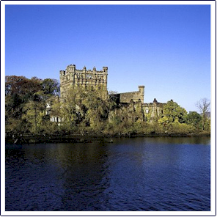
Paddled 22 miles on the Hudson River on Sunday, 11.8.09. Launched at Cold Spring Foundry Park at sunrise and paddled up to Bannerman's Castle, then up to the Newburgh-Beacon Bridge, then down to West Point, and south to Duck Island (you can see Bear Mountain Bridge from there) and back up to Cold Spring. A lot of miles and a lot of spectacular scenery.

*A lot of the photos weren’t ones I took myself, as I had too many miles to cover so I cribbed them from elsewhere, but it was what I was seeing as I paddled along.

Link to Shutterfly Album

