Soundkeeper’s Lighthouse to Lighthouse Race

Official Race website http://l2l.soundkeeper.org

This fourteen/seven mile race is open to all seaworthy human powered vessels. The second, shorter course of 7 miles is for those who do not wish to race 14 miles. All profits from the race benefit Soundkeeper, a 501c3 non-profit group whose mission is to protect the ecology of the Long Island Sound community, and promote the Sound as a viable recreation area.

On September 13, 2008, I had been the proud owner of my 17 foot sea kayak for only three week, and barely knew which end of the paddle to hold, but having been a competitive athlete all my life, I decided to enter the L2L race. The race is the open waters of Long Island, and I was terrified I might capsize, as I did not yet know how to do an Eskimo roll and the wakes from powerboats can come crashing over the full of your boat. Nevertheless, I determinedly lined up by boat at the start of the 7-miler (never having paddled 7 miles in my life), with #38 duck taped to the bow of my boat, grit my teeth and paddled like a mad woman. I ended up winning a Gold Medal in my category (women’s sea kayak).

********************************
Link to Shutterfly Album

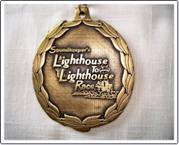 | 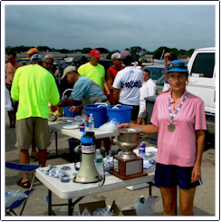 | 