1st place, Milford Oyster Festival Women's Kayak Race
August, 15, 2009

The Mayor of Milford handed out the awards.

The 1st Place Trophy is nearly as big as I am!
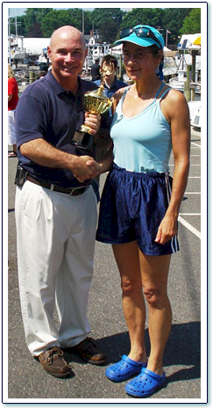

Link to Shutterfly Album

