Navigation at Sea

Learning to navigate at sea was one of the goals of my training for the Blackburn Challenge, which is a 20 mile race in the open ocean, circumnavigating Cape Ann, in Gloucester, Massachusetts. On the day of the race, a blanket of fog rolled in that was so thick I could not see the land so I put my newly-learned navigation skills to the test!

For background, I first studied Map and Compass on land, and practiced on Orienteering courses, and entered a few Orienteering Races.

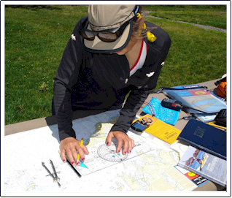
In studying coastal navigation and tidal planning, I learned to interpret maps and charts, and tide tables; learned to apply a weather forecast to a marine environment, learned how to do dead reckoning and use a compass to chart a course. I studied about weather: the cause and effect of weather systems and fronts, and sea conditions associated with weather. I learned about tides: the basic cause and effect of tidal movement on a daily and monthly basis, spring and neap tides, and how this related to trip planning regarding timings, sea conditions, launching and landing. I learned how to use a VHF radio. I learned how to take true and magnetic bearings, and where to find longitudinal and latitudinal lines. I also studied about scales and measurements using Nautical miles, land miles, as well as kilometers and became aware of the value of working in nautical miles on the sea, as tidal information is given in knots. Last but not least, I learned the United States Coast Guard Rules of Road.

It truly was quite an education! But it was one that made me more safety conscious and also enabled me to plan my solo journeys, first of 22 miles on the Hudson River, then of 100 miles on the CT River, all of which required extensive use of my training in navigation at sea.

Link to Shutterfly Album

