Run of the Charles
Cambridge, Massachusetts 2009

Official race website: http://www.crwa.org/rotc/rotc.html

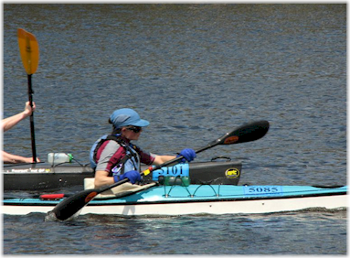
The Run of the Charles is attended by competitors from all over the country and is held on the Charles River. It was quite fun paddling in my old college stomping grounds, up and down the race course on the Charles River, past the Harvard River House Dormitories, the domes of the University Buildings, Weld Boat House for the Harvard Men and Women’s Crew Team and under various Charles River bridges, including the Boston University Bridge. The Sally Mermaid Banner was unfurled and is hanging from one of the bridges I paddled under. The banner was taken from the name plate on my boat, and was hung for my encouragement.

I came in Third Place, merely a few seconds out of Second Place.

Link to Shutterfly Album

