Carol Leavitt Altieri Introduction

Audubon Photo – Chatham, Cape Cod 8/6/09

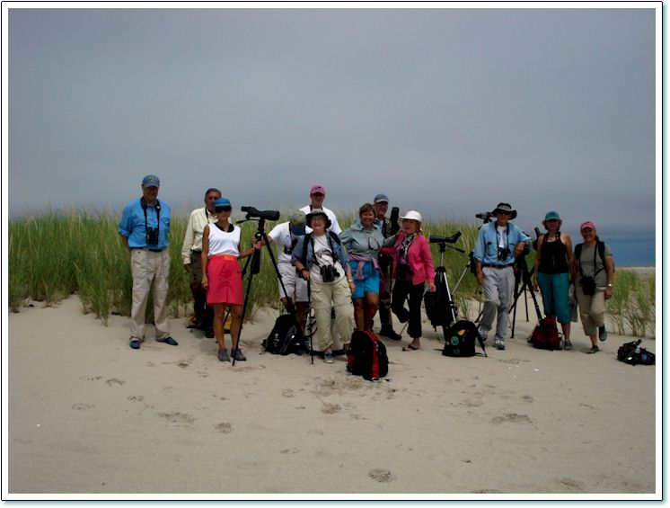

That lady with the colorful hat, dressed very much like a poet, IS a poet and is here tonight. She is Carol Leavitt Altieri, a talented poetess who has published several volumes of poetry. Her most recent book of poems, the Jade Bower, was published late last Fall. I bought it as a Christmas gift to myself and it is on my Gear Show & Tell Table.

Carol’s remarkable gift for Nature Poetry is eerily similar to my approach to hiking, where we both take in all the sights and sounds of Nature, and go the next step of identifying them. There is a spiritual connection there.

At the end of my Talk I will introduce Carol to you, so that any of you here that are interested in poetry may have a chance to chat with this remarkable lady.

