Differences Between State Agency Disability Determinations and Hearing Decisions
There are significant differences between the way disability is evaluated by the state agencies and the way ALJs approach the issue. Although it is the rule at all levels that a disability decision cannot be inconsistent with the medical evidence, the state agency decision-makers, who have only the cold file to review, seldom look beyond medical findings to consider your actual ability to work. At the state agencies, the Listing of Impairments is used much more often as a basis for a favorable decision. Despite several successful lawsuits challenging this, state agency decision-makers tend to use the Listing of Impairments as the unstated basis for a denial determination, especially for those claimants under age 50.
If a younger claimant’s impairment does not meet a Listing, that claimant is unlikely to be found disabled by the state agency. State agency decision makers tend to apply specific formulas (found in state agency manuals) to determine residual functional capacity (RFC) for certain medical impairments, thus treating all claimants with similar medical findings the same. Few of the state agency formulas point to a conclusion that a claimant can do less than a wide range of sedentary work.
ALJs, on the other hand, tend to view medical findings as setting the parameters for a range of possible RFCs, some of which may lead to a finding of disabled. They view their role as evaluating the entire case, including your credibility, to determine which possible RFC most closely describes your capacity. ALJs find claimants under age 50 disabled because of inability to perform a wide range of sedentary work much more often than state agency decision makers do.
The chart in below was created in conjunction with a Social Security Administration study of the differences between state agency decisions and ALJ decisions. It shows, for example, that during the period studied, ALJs found claimants with back impairments disabled 75% of the time while the state agency did so only 11% of the time. Look at the entry for claimants under age 50 with back impairments. The state agency found them disabled only 2% of the time while ALJs found them disabled 68% of the time.

State Agency and ALJ Disability Decisions Compared
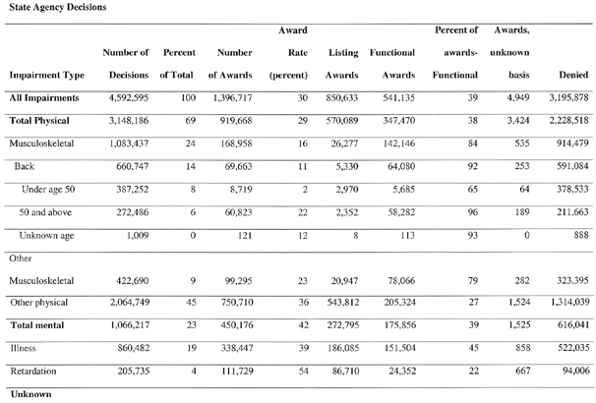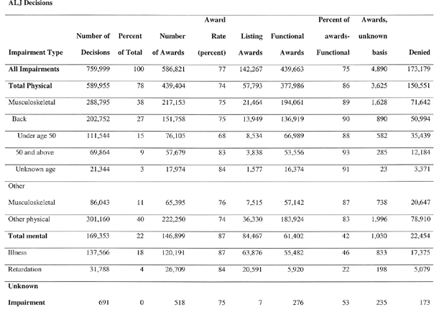
Compare the “Percent of awards—Functional” column, referring to the percentage of findings of disabled made at step 5 of the sequential evaluation process (as opposed to finding the claimant disabled at step 3 on the grounds that the claimant’s impairments meet the Listings). Only 39% of all disability findings were made by state agency decision makers at step 5 compared to 75% of awards made at this step by ALJs.
The SSA has viewed these differences in approach to decision-making as a problem. The series of Social Security rulings published in 1996, SSR 96-1p through SSR 96-9p, known as the “process unification rulings,” were designed to encourage a unified approach to decision making at all administrative levels. Most observers agree that there have been some changes. More claimants are now found disabled by the state agencies. There are fewer favorable decisions being issued by ALJs now than when this study was conducted. But most observers agree that the disparities illustrated by the chart above remain in place. For example, if a claimant is under age 50 and has a back problem that does not meet the Listings, that claimant is likely to be denied by the state agency; but if that claimant is truly unable to work, the claimant may have a good chance of winning before an ALJ.

